St. Mary’s P.S and Cill Chluana Parish Nursery | 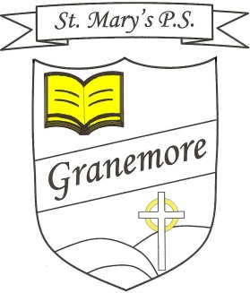  Learning through faith, laughter and love. | 123 Granemore Road  Tassagh  Co Armagh  BT60 2NJ
Principal: Mrs B Casey  bcasey632@c2kni.net |  | Telephone: 02837538018  Facsimile : 028 37538018

Dear Parent/Carer

Our Book Fair will be arriving on Thursday 12th May. This is a very exciting time for the children and is a great opportunity to further promote reading in our school. Thursday will be for children’s viewing only, for anyone wishing to purchase books our opening times are below.

There are over 200 titles for you and your child to choose from, and with prices starting from only £2.99, there’s sure to be a book for everyone.

Book Fair opening times will be:

Friday 13th May - 8:45 – 9:30am (Hall) and 1:45 – 3:30pm (Hall)
Monday 16th May - 8:45 – 9:30am (Hall) and 1:45 – 3:30pm (Hall)
Tuesday 17th May – 8:45 – 9:30am (Hall) and 1:45 – 3:30pm (Hall)
Wednesday 18th May - 8:45 – 9:30am (Hall) and 1:45 – 3:30pm (Hall)

Please note that children may also bring in their order and money to their class teacher if parents are unable to attend. Children with money can purchase books through the day with their teacher, each class have been given a time for their class to make purchases (Children are not permitted to purchase books during the above times unless accompanied by an adult).

We greatly appreciate your continued support for our book fair, as this enables us to obtain more reading books and resources for our school and your children.

Kind regards
Mrs Stephanie Reilly
(Vice-Principal)

