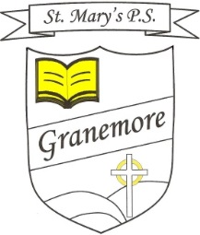

1-04-2021
Dear Parent
Schools closes today for our Easter holidays and reopens on Monday 12th April.
Please note that Primary 3 will stay in school until 3pm from the return date.

Other News
The dinner menu for all of term 3 is now available on our school website. The dates are listed along the side for each week. This is a new way of presenting the menu and we hope you find it easy to use. Mrs Murray has introduced some new dishes and we hope the children will try out the different foods. It is important that you check that your child likes the listed dinner for the day, before ordering it.
Holiday List
Please note that the two planned staff training days on Tuesday 1st and Wednesday 2nd June are now changed to Monday 14th and Tuesday 15th June. Therefore, school will be closed to pupils on these two days.
Sensory Walk
Our pupils enjoyed a fabulous ‘sensory walk’ last week, which brought them around the football field and through some lovely sensory experiences at various points on the walk. They were then treated to an Easter egg hunt and everyone left with an egg! This event was organised by the local club and their volunteers made sure that everyone had a most enjoyable morning. Our sincere thanks goes to Paula, Sharon, John, Aileen, Jenna, Jenny, Annie, Bebe, Anne, Roisin and Ailish for organising and overseeing this great outdoor experience for all our pupils.

We are looking forward to seeing everyone back for our summer term on Monday 12th April 21.

On behalf of the staff and our Board of Governors, may I wish all our school community a happy and holy Easter.

Yours sincerely
Mrs Brenda Casey

