St. Mary’s P.S and Cill Chluana Parish Nursery | 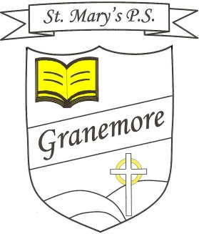  Learning through faith, laughter and love. | 123 Granemore Road  Tassagh  Co Armagh  BT20 2NJ
Principal: Mrs B Casey  bcasey632@c2kni.net |  | Telephone: 02837538018  Facsimile : 028 37538018

Dear Parent 19-03-2021

We welcome our Primary 4-7 pupils back to school on Monday 22nd March and we are very much looking forward to having all classes in school once more.

The routines for drop off and pick up, which applied in Term 1, will come into action again from Monday and we ask that you adhere to social distancing at the gate and avoid congregating in groups while dropping off or waiting for your child.

Pupils may be dropped off in the mornings between 8.45am and 9.15am and should use the pedestrian gate only. (Pupils should not be arriving after 9.15am as lateness is very unsettling for a child and disruptive for the whole class and teacher).
Pupils should go promptly to their classrooms.
(Staff will be present at the gate on Monday morning to reassure any of the children who may be feeling a little anxious).

Pick up times and locations are listed below.

P1 (1.50pm)
P2 (2pm) at pedestrian gate,
P3 (2pm) at top gate

P4 (2.50pm)- Top gate
P6 (2.55pm)- Top gate

P5 (2.50pm)- pedestrian gate
P7 (3pm) at pedestrian gate.

PE uniform may be worn up until Easter and we will return to full uniform for term 3.

The buses are back to normal operation from Monday and children are required to wear a mask on the bus and sit in class groups or with family members, as before.

Our canteen menu is available to view on the school website.

Other News
Thank you to those pupils who shared their fantastic St Patrick’s Day performances with us. Our very talented pupils can be viewed on the school website.

Reminder
P3 pupils will remain in school until 3pm in Term 3.

Congratulations!
Our P6 and P7 classes recently composed poems around the subject of looking after our mental health in these difficult times. The teachers chose a winner from each class and these were then entered in a competition, organised by Aware NI.
We are very proud of Ross Lappin, in P6, who secured 3rd place in the entire competition, winning an individual prize and also many wonderful prizes for his class! We will feature Ross and his brilliant poem on our website next week.
Congratulations Ross on your wonderful achievement. Maith thú!

At present the dates for First Communion (1st May) and Confirmation (16th April) remain the same. I will be in touch should these change. More details will follow.

Looking forward to seeing all our pupils on Monday morning.

Yours Sincerely

Mrs Brenda Casey

