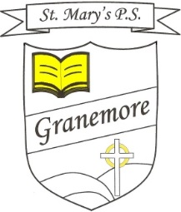
20-02-2021

Dear Parent
You will be aware of Thursday’s executive announcement regarding schools and the proposed phased return of different age groups over a period of time.
On Monday 8th March, we welcome the return of our Nursery, P1, P2 and P3 classes to their classrooms and to a normal school day (9am-2pm). This is great news and we are delighted to have a degree of normality returning for some of our pupils. These classes will be in school for two weeks, excluding Wed 17th March, which is a holiday. From Monday 22nd March to Friday 29th March, these four classes will go back to remote learning from home. The following week will then be the Easter holidays for all. It is hoped that all pupils will return after Easter but this is under review and a decision on this will be made by the executive nearer the time. Details on the return for the N-P3 classes will be shared with parents prior to the 8th March.
We continue to provide ‘supervised learning’ for pupils who are vulnerable or have a ‘key worker’ parent and this facility resumes on Monday 22nd February. Please get in touch by email should you require further information on this.

Thank you for your continued support.
Mrs B Casey

