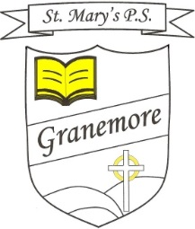

Friday 22-05-2020
Dear Parent
I hope you and your families continue to keep healthy and well in these strange times.
School has been closed now for 10 weeks. We appreciate that it is difficult to keep the children motivated in completing set tasks and the teachers are continually striving to improve their home learning approaches. We urge you to keep in contact with the class teacher and to bring to their attention any issues or challenges you may be facing.
I’m sure you will have heard yesterday’s announcement regarding the reopening of schools here in the latter part of August. We have no further guidance around this but will keep you fully informed of plans when we are given more information.
Thank you for encouraging your children to set up their May altar at home. This is a lovely tradition and we are delighted that it was carried on in homes this year. Thank you also for all the rainbow pictures and the effort that went into these.
Mrs McGeary is putting together a special tribute this week and is asking our past pupils and current parents who work for the NHS and are key workers, to email tmcgeary910@c2kni.net their photograph (perhaps in uniform at work) by Wednesday 3rd June.
We have posted, on our website, some articles and ideas around awareness of mental health and encourage you to have a look at these. I have asked the children (on the video clip) to carry out an act of kindness over the weekend. This is to tie in with mental awareness week.
Fr Greg has posted a lovely message on the website so please encourage the children to watch this.
The teachers have given the boys and girls a break from work on Monday and Tuesday of next week. We thought it would be a welcome break for parents and pupils alike and would hopefully recharge the motivation levels to see us through to the end of term!

Have a lovely bank holiday weekend.
Kind regards
Mrs Brenda Casey

