St. Mary’s P.S and Cill Chluana Parish Nursery | 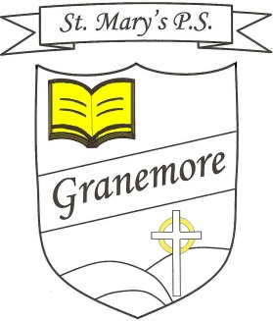  Learning through faith, laughter and love. | 123 Granemore Road  Tassagh  Co Armagh  BT60 2NJ
Principal: Mrs B Casey  bcasey632@c2kni.net |  | Telephone: 02837538018  Facsimile : 028 37538018

Dear Parent/Carer

This year we will be celebrating World Book Day on Thursday 5th March. Due to the success of previous years we will again be running the theme of ‘Bedtime Stories’. We are asking each child to bring in their favourite bedtime teddy, so that we can share a hot chocolate drink and cookie while listening to some of our favourite bedtime stories.

Kind regards
Mrs S Reilly
(Literacy Co-ordinator)

