2024 White’s Oats Armagh International Road Race Juvenile Races

Hope you are all looking forwards to a great night of racing on Thursday night. In preparation for race night can I draw your attention to the following points. Please note parents cannot run down the outside of the course (St Mark’s Church side) during the race (with the exception of Race 5). Any parents attempting to run down this side will be stopped by marshals and directed to the inside of the Mall after the race has passed. This has been a significant health and safety risk in previous years during races 1-4. Please see note #5 re collection of children after their race.

1) Numbers
Numbers can be collected from the Crozier Hall from 4pm on Thursday. Pins are provided and numbers should be pinned to the front of the athlete’s top.

2) Start Area.
All the White’s Oats Juvenile races start from the same start point (Jail end of Mall East). 400m races run from the start to the finish. 1400m races run 1 lap plus the start-finish stretch (in a counter-clockwise direction). Please ensure the runners are in the start area in time for their races as the races will start on time.

3) Spectators.
Spectators must remain behind the barriers on the inside of the Mall. With the exception of Race 5, parents cannot run the race alongside children (see below re finish area and child collection).

4) Finish Area.
The finish area is closed to all spectators – only race officials and registered photographers are allowed in this area. There will be an area outside of the barriers where parents / coaches can take photos of the presentations.

5) Collection of Children.
At the end of each race, children will be escorted across from the finish area to the child collection area, which is situated at the courthouse end of the mall, adjacent to the finish. Children who have finished in the top ten will have their presentation within the finish area. After the presentations the children will be escorted to the child collection area.
Children are to be collected from the child collection area only with no exceptions.
6) Photography.
Armagh AC will have a club photographer taking photographs of the top ten presentations which be posted to social media. If any of the children do not wish to be included in these photographs could you let me know so I can ensure the children are not in the photos posted online.

7) Senior race presentations.
Senior race presentations, including Junior ‘A’ and ‘B’ categories, and post-race food and drink will take place in the Crozier Hall after the finish of the Men’s Open 3K race at approximately 21:30-21:45.

8) School team competition.
We will be awarding school team prizes with large and small school primary school categories and male and female post primary school categories. Primary schools have been designated as large or small based on pupil numbers. Team points are awarded on a reducing basis for the first 25 athletes in races 1-5 and the first 50 athletes in races 6-11 and 3k male / female junior A and B categories. We will award these prizes to the schools in the weeks after the event.

If you have any queries, please contact me at armaghroadracejuniorentries@gmail.com. See you on the Mall.
WHITE’S OATS JUVENILE RACES
Race 1 Boys 2017 (GCS Solicitors) 6.30pm 400m
Race 2 Boys 2016 (Francis Haughey, Building & Civil Engineering Contractor) 6.35pm 400m
Race 3 Girls 2017 (Mulberry Bistro) 6.40pm 400m
Race 4 Girls 2016 (Nettlehill Service Station) 6.45pm 400m
Race 5 Special Olympics (NCC IT Services) 6.50pm 400m
Race 6 Boys 2014/15 (FK Lowry) 6.55pm 1400m
Race 7 Girls 2014/15 (Demesne Mechanical and Electrical Engineering Ltd) 7.05pm 1400m
Race 8 Boys 2012/13 (CK Rafferty Solicitors) 7.20pm 1400m
Race 9 Girls 2012/13 (Pat Brannigan Commercial Mediator) 7.30pm 1400m
Race 10 Boys 2010/11 (Cycleology/Cup & Cone) 7.40pm 1400m
Race 11 Girls 2010/11 (Embers Restaurant) 7.50pm 1400m

ARMAGH SPORTS AND TROPHIES INTERNATIONAL WOMEN’S 3k (Snr women + V35/40/45/50/55/60/65 + FJA 2006/07 + FJB 2008/09)
Race 11 8.10pm 3000m College St + 2 laps
SPORTSSHOES.COM INTERNATIONAL 5k (confined to athletes 16mins or under)
Race 12 8.30pm 5000m Russell St + 4 laps
LINWOODS OPEN MEN 3k (Open Men + V40/45/50/55/60/65/70 + MJA 2006/07 + MJB 2008/09)
Race 13 8.55pm 3000m College St + 2 laps

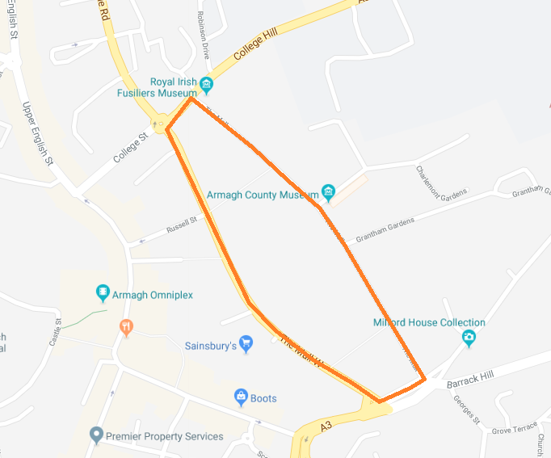
Start Races 1-11
Start 3K/5K
Finish
(all races)
Crozier Hall (race number collection)
Child Collection Point

