St. Mary’s P.S and Cill Chluana Parish Nursery | 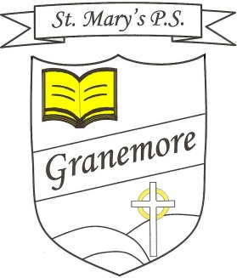  Learning through faith, laughter and love. | 123 Granemore Road  Tassagh  Co Armagh  BT20 2NJ
Principal: Mrs B Casey  bcasey632@c2kni.net |  | Telephone: 02837538018  Facsimile : 028 37538018

Dear Parent/Guardian, 10-01-2023

RE: Afterschool Clubs
Afterschool clubs for term 2 will run for a total of 10 weeks. We will be running the following clubs from Monday 16th January to the week of Monday 27th March.
Day | Class | Activity
Monday  Irish Dancing (All) | P1-P3 (All) | Irish Dancing (2-3pm)
 | P4-P7 (All) | Irish Dancing (3-4pm)
Tuesday  **Hip-Hop | P2-3 (All) | Hip-Hop (2-3pm)
 | P6-7 (All) | Hip-Hop (3-4pm)
Wednesday  **Gaelic Football | P2-3 (All) | Gaelic Football (2-3pm)
 | P4-5 (All) | Gaelic Football (3-4pm)

Club | Duration | Cost | Payment
Irish Dancing | 10 Weeks | £35 | In a marked envelope directly to Mrs L Scallon.
Hip-Hop | 10 Weeks | £40 | School App
Gaelic Football | 10 Weeks | £40 | School App
Club Dates
Monday  Irish Dancing | 16th  Jan | 23rd  Jan | 30th  Jan | 6th  Feb | Mid  Term  Break | 20th  Feb | 27th  Feb | 6th  Mar | 13th  Mar | 20th  Mar | 27th  Mar
Tuesday  Hip-Hop | 17th  Jan | 24th  Jan | 31st  Jan | 7th  Feb |  | 21st  Feb | 28th  Feb | 7th  Mar | 14th  Mar | 21st  Mar | 28th  Mar
Wednesday  Gaelic Football | 18th  Jan | 25th  Jan | 1st  Feb | 8th  Feb |  | 22nd  Feb | 1st  Mar | 8th Mar | 15th  Mar | 22nd  Mar | 29th  Mar
**Afterschool clubs that are run by Burns Skills School are limited to a maximum of 20 places. Therefore, places will be offered on a first-come-first-served basis.
To pre-book a place, please phone the school office. When places are filled, payments will then be made available from Monday 16th January via the school’s app and permission slips will then be issued for each pupil.
If spaces are not filled, they will be offered to a selected class.

Yours Sincerely
Mr. M. Murray

