St. Mary’s P.S and Cill Chluana Parish Nursery | 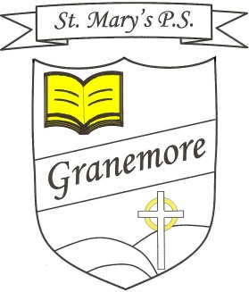  Learning through faith, laughter and love. | 123 Granemore Road  Tassagh  Co Armagh  BT20 2NJ
Principal: Mrs B Casey  bcasey632@c2kni.net |  | Telephone: 02837538018  Facsimile : 028 37538018

Dear Parent 03/09/21

Welcome back to another school year and we warmly welcome all of our new children into our school community. All of the children have settled back into the school day and the new routines of their new classes.

Homework and reading will begin the week of Monday 13thSeptember. Each teacher will provide you with details of your child’s homework. Pupils will be sent new log in details for Seesaw/Google Classroom home next week. However, this is only in the event of a local or widespread lockdown occurring. All relevant information regarding your child should still always go through our school office and not via the above applications.

We welcome back Mark from Healthy Kidz for all classes from Friday 10th September. Your child’s teacher will notify you of any other PE days.

Our music service will resume next week with our current P7 class – Wednesday strings and Thursday wind instruments. Primary 5 and 6 children will be offered a chance to avail of these services also, more information will follow next week.

Please continue to wipe down lunchboxes and folders when they return home and before they come back into school. Our school money app unfortunately is still not up and running as we are awaiting the company to process our details. We will notify you when the app is ready for use.
We continue to urge you to keep your child at home, should they feel unwell. You are advised to seek a test should they present with any Covid19 symptoms, namely a cough, temperature, sore throat, headache and/or loss of smell or taste. (see Information for parents/carers leaflet on our website).
Congratulations to Conor Grimley in P4 on winning the Farm Safety competition. Conor’s drawing will feature in April, in their calendar that will be distributed to all primary schools throughout Northern Ireland. We are extremely proud of Conor and his achievement at winning such an accolade.
For future reference please refer to our school website for any other forthcoming information pertinent to your child’s school day.
Dates for the diary

Wed & Thurs – Music services commence
Thursday 9th Sept - P1 Ulster Gazette photographer for new P1 picture.
Friday 10th Sept – Healthy Kidz return
Monday 21st Sept - Afterschool clubs to return (details to follow shortly)

Yours Sincerely

Mrs Stephanie Reilly (Vice-Principal)

