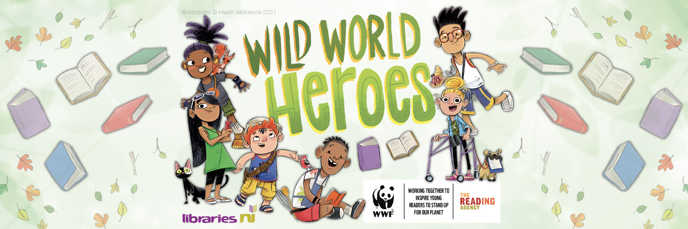
22 June 2021
Dear Community Planning Partner,
Introducing Libraries NI ‘Summer Reading Challenge’ - 19 June until 18 September 2021
Wild World Heroes, Summer Reading Challenge 2021; a celebration of nature and action for the environment, in partnership with WWF UK.
Get ready for Wild World Heroes, arriving online and in libraries across Northern Ireland this summer.
Children age 4 to 11 can join the World Wide Heroes for this year’s Summer Reading Challenge to discover how they can make a difference to the environment.
Produced by The Reading Agency and delivered in partnership with libraries, we’re teaming up with WWF for a very special nature themed challenge that will inspire children to stand up for the planet.
The challenge will feature amazing books, awesome rewards and plenty of ideas for taking care of the environment.
How does it work?
The Summer Reading Challenge will take place from 19 June until 18 September 2021
Children can sign up at their local library, choose their reading goal then read any books to collect special stickers and other rewards along the way – all for FREE. There is a digital platform too, so the fun can carry on at home!
Children can read whatever they like in their chosen format – fiction, fact books, poetry, joke books, picture books, graphic novels, audio books and eBooks.
Everyone who completes their personal challenge will receive a certificate and medal.
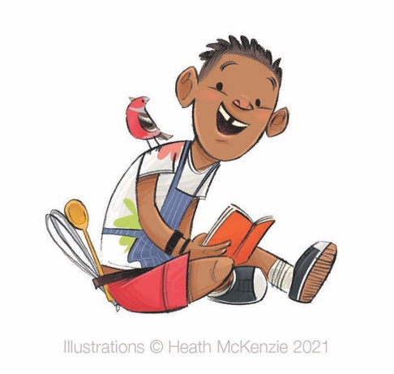
Events and activities will take place throughout the summer online and possible face-to-face depending on guidelines issued by the Northern Ireland Executive.
Why should children take part?
Children's reading can 'dip' during the long summer holidays if they do not have regular access to books and encouragement to read for pleasure.
The Reading Agency’s annual Summer Reading Challenge really helps by getting over 700,000 children regularly into libraries over the summer, with thousands more taking part online.
There is no other free reading activity that involves so many children, introduces families to their library, encourages children to choose books freely and independently and is endorsed by parents and teachers.
Video
Watch our short video to find out more https://www.youtube.com/watch?v=CgMzwIOrTXQ
How can you support the Summer Reading Challenge?
- Make others aware - support Libraries NI on social media and point children to local libraries in your area
- Bring your own children along to participate
- If you can display marketing material and posters then contact marketing@librariesni.org.uk
To find out more please visit our website www.librariesni.org.uk

