St. Mary’s P.S and Cill Chluana Parish Nursery | 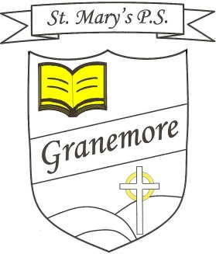  Learning through faith, laughter and love. | 123 Granemore Road  Tassagh  Co Armagh  BT60 2NJ
Principal: Mrs B Casey  bcasey632@c2kni.net |  | Telephone: 02837538018  Facsimile : 028 37538018

Dear Parent 25th August 2020

First Communion update

Following the most recent PHA advice on public, indoor gatherings, we have been forced to reconsider our arrangements for our First Holy Communion mass this Saturday.

Our original decision to allow siblings to attend has had to be changed and we can now only facilitate our First Communicants and their parents in the church. This decision has not been taken lightly, but allowing all the family to attend would amount to in excess of 130 people.

We know this will be very disappointing for all families involved, but the safety of our children and the community is our priority in these difficult times.

We look forward to sharing this special occasion with you and hope we can make it as memorable as possible for the children in the circumstances.

Kind regards

Mrs Brenda Casey

