Get school updates via your phone
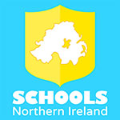
Our school is now listed in the Schools NI app, which allows you to view school updates and receive messages via your phone or tablet. The app is available on both Apple and Android devices, and will give you access to our school news, calendar events and letters.

To install the app, open [School Website] on your phone or tablet and click the ‘Download App’ button that appears at the top of the screen.

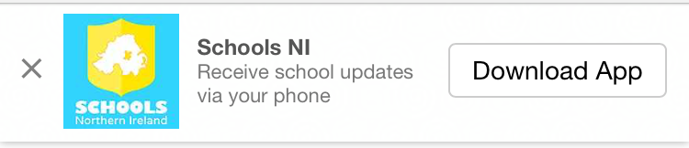

Next time you open the Schools NI App our school will be listed at the top of the list. You don’t need to have the app open to receive messages.

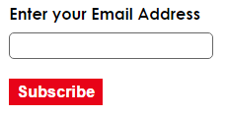
Get school updates via your email

Email updates are now available through the school website. Please visit [school website] and enter your email to receive regular messages from the school.

Select year group options to receive specific year group messages.

