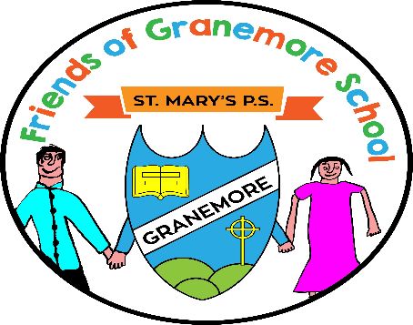

Dear Parents/Guardians

Re: Friends of Granemore School Annual General Meeting (AGM)

I hereby give notice of the AGM of Friends of Granemore School to be held on Wednesday 22nd June. The meeting will commence at 8pm in Dining Hall.

Friends of Granemore School has been set up by the school, and will play a vital part in the school community. All parents, guardians and grandparents are invited to support the AGM.

If you would like any further information about what is involved in being a Committee Member, please email: friendsofgranemoreschool@hotmail.co.uk

This is your opportunity to make a real difference in your child’s school life and the wider school community. We look forward to seeing many new faces Wednesday 22nd June.

Kind Regards

Collen Firth (Chair)

Friends of Granemore School

__________________________________________________________________________________

