Programme Outline
The structure of You Shall Be My Witnesses is based on the sections of the Catechism of the Catholic Church:
- What we believe!
- What we celebrate!
- What we live!
- What we pray!
There are Five Sessions
Session 1 Belonging
How do I belong?
Session 2 Believing
What do I believe?
Session 3 Being a Christian
How can I be a Christian?
Session 4 Becoming a Witness
How do I share the Good News?
Session 5 Beginning Again
What happens next?
Note:
This programme is usually delivered in a parish setting with volunteers who facilitate the programme. Parents are encouraged to join in at the end of each session for prayer. Children are asked to complete some tasks and worksheets at home and these activities provide a conversation for both the parents and children around the topics discussed in each session. In the light of the current situation I would like to encourage all members of the family to provide the support and encouragement needed to prepare your child/ children for the sacrament of confirmation.

Acknowledgement:
I would like to offer my sincere gratitude to Maeve Mahon, who developed the You Shall Be My Witnesses programme for parishes and for giving us permission to use this wonderful resource in a new way to help our Confirmation candidates prepare for the Sacrament of Confirmation

Providing a Sacred Space
In order to deliver each session, I invite you to create a sacred space in your home. This sacred space will also serve as a focus of prayer at the end of each session.
You will need:
A candle (battery is safe)
A white or red cloth
A cross or Bible (or both)
(insert image of a sacred space)

Session 2
Believing: What Do I Believe?
Start the session by lighting the candle and saying the opening prayer together.
Opening Prayer
Lord Jesus Christ, Son of the living God pour out Your Holy Spirit upon us, especially upon ___________________ (child’s/children’s name (s)) as he/ she/they prepare for the sacrament of confirmation. Amen

In this session we are going to look at what we believe as members of the Catholic Church. In the last session we mentioned that Confirmation is a time when you say “YES” to the faith that your parents, family, community and school have supported you in for the last 11 or 12 years.

(Insert image of a faith community)

Activity
Candle of Faith
Write the names of the people and places where you have learned about your faith on the candle. Encourage each member of your family to participate in this activity.

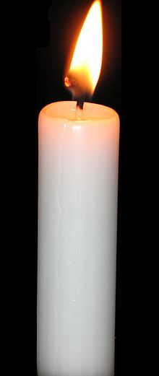

The Nicene Creed
I believe in one God, the Father almighty, maker of heaven and earth, of all things visible and invisible.
I believe in one Lord Jesus Christ, the Only Begotten Son of God, born of the Father before all ages. God from God, Light from Light, true God from true God, begotten, not made, consubstantial with the Father; through him all things were made. For us men and for our salvation he came down from heaven, and by the Holy Spirit was incarnate of the Virgin Mary, and became man. For our sake he was crucified under Pontius Pilate, he suffered death and was buried, and rose again on the third day in accordance with the Scriptures. He ascended into heaven and is seated at the right hand of the Father. He will come again in glory to judge the living and the dead and his kingdom will have no end.
I believe in the Holy Spirit, the Lord, the giver of life, who proceeds from the Father and the Son, who with the Father and the Son is adored and glorified, who has spoken through the prophets.
I believe in one, holy, catholic and apostolic Church.
I confess one Baptism for the forgiveness of sins and I look forward to the resurrection of the dead and the life of the world to come. Amen

There are two creeds prayed in the Catholic tradition:
- The Apostles’ Creed.
- The Nicene Creed.
The word ‘creed’ comes from the Latin word ‘credo’ and it means ‘I believe’.
The Creed we say at Mass almost ever Sunday is the Nicene Creed, which was first written in ad 325, almost 1,700 years ago.
The Creed was written at a meeting of Christians called by the Emperor Constantine and held at Nicaea (in modern Turkey) in the year 325.
People came from what were then the five main centres of Christianity:
- Rome
- Constantinople
- Jerusalem
- Antioch
- Alexandria
Emperor Constantine wanted them to agree on the most important things that all Christians should know. The members of the council wrote down a number of simple facts and truths that could be learned off by heart by Christians.
The Nicene Creed was completed at the Council of Constantinople in ad 381.

The Apostles’ Creed is so called because it dates from the time of the Apostles. It tells us of the important things that the Apostles taught about God, Jesus and the Holy Spirit.
There is little doubt that the Nicene Creed is based on the Apostles’ Creed.
The Apostles Creed
I believe in God,
the Father Almighty,
Creator of heaven and earth,
and in Jesus Christ, His only Son, our Lord,
who was conceived by the Holy Spirit,
born of the Virgin Mary,
suffered under Pontius Pilate,
was crucified, died and was buried;
He descended into hell;
on the third day He rose again from the dead;
He ascended into heaven,
and is seated at the right hand of God the Father Almighty;
from there He will come to judge the living and the dead.
I believe in the Holy Spirit,
the Holy Catholic Church,
the communion of Saints,
the forgiveness of sins,
the resurrection of the body,
and life everlasting.
Amen.
Can you find the five centres of early Christianity on the map?
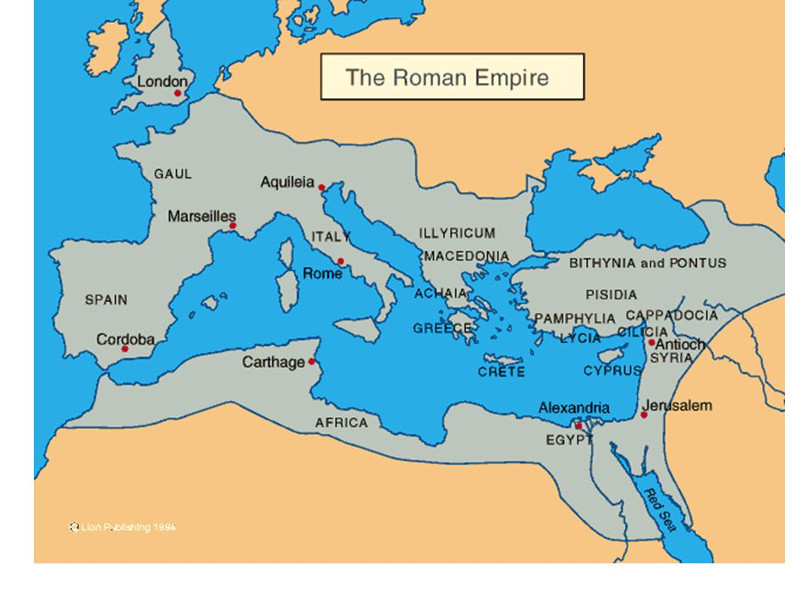

The Creed is a prayer that we say at Mass every Sunday. It sums up what we believe as members of the Church. Another name for it is the Profession of Faith, because we say it out loud, we are stating what we believe as Catholics. Read it with your family.

We can break the Creed into three sections:
- The first section is about God the Father.
Why do you think God the Father comes first?
- The Second Section is about Jesus.
What did you notice about the second section?
- The Third Section is about the Holy Spirit.
What does this section tell us about the Holy Spirit?

Quiz
How many times do we say the Words ‘I believe’ during this prayer?
What does the Creed tell us about God the Father?
What invisible things do you think God has created?
What does the Creed tell us about Jesus?
What does the Creed tell us about the way in which the Holy Spirit speaks to us?

The Prophets
What is a ‘Prophet’?
The prophets in the bible tell us about God, and how God wants us, his people to live our lives. Some of the prophets you may have heard about at Mass are:
- Isaiah
- Samuel
- Jeremiah
- Ezekiel
- Daniel
A prophet is someone who looks at what is going on in the world around them and changes people to make it a better place. Sometimes they say things we would rather not hear. They challenge us about the way we are living our lives.
Maybe we are not doing enough to care for those who are less fortunate than us; perhaps we are not caring for the earth properly. Maybe we could be trying harder to be better Christians and members of our Church.

There are lots of modern – day prophets. People who are alive today or who lived not very long ago. Can you think of any prophets in today’s world?
- Pope Francis
- Greta Thurnberg
- Mother Teresa
- People who work for Trócaire or other charities
- Priests
- Religious Brother and Sisters
- Parent/ Grandparent/ Godparent
Do you know any modern-day prophets? Ask your family to help you choose either someone from the list above or someone in your local community who is a modern-day prophet. What might a modern- day prophet speak about/do? Write a few lines about the person you chose and what makes them a modern-day prophet?
The Church
The end of the Creed is about the Church and what we believe in as members of the Church! This part of the Creed is also reminding us that because we are baptised, because we believe, together we are the Church, the Body of Christ. When we talk about the Church in the Creed, we are not talking about a building that we go to every Sunday, but about all the people around the world who believe in and belong to the Church.
The four words to describe the Church are:
- One
- Holy
- Catholic
- Apostolic
One, because it comes for the One God, Father, Son and Holy Spirit.
Holy, because God is Holy and it is God’s Church
Catholic, the word comes from the Greek language and means universal. The Church can be found all over the World. It also means hospitable, welcoming and open.
Apostolic, reminds us that it was the Apostles who continued the work that Jesus began, of spreading the Good News.
If we truly believe what we say when we profess our faith in the Creed, then we must carry on the work of the Apostles in our world today.

Activity
Write one thing in each of the following sections about what you believe. This can be your creed!
WHAT I BELIEVE ABOUT……….

God the Father
…………………………………………………………………………………………………………………………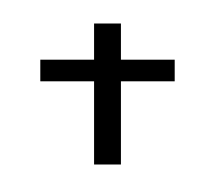
………………………………………………………………………………………………………………………………………………………………………………………………………………………………………………………………………………………………………………………………………………………………………………………………………………………………………………………………………

Jesus

…………………………………………………………………………………………………………………………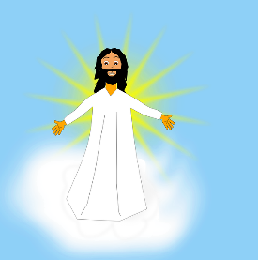
……………………………………………………………………………………………………………………………………………………………………………………………………………………………………………………………………………………………………………………………………………………………………………………………………………………………………………………………………….

The Holy Spirit
………………………………………………………………………………………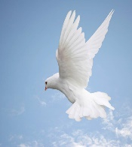……………………………………………………………………………………………………………………………………………………………………………………………………………………………………………………………………………………………………………………….

The Church

…………………………………………………………………………………………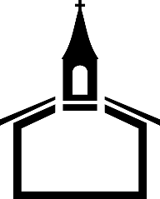
……………………………………………………………………………………………………………………………………………………………………………………………………………………………………………………………………………………………………………………….

Closing Prayer
Lord Jesus Christ Son of the living God, pour out Your Holy Spirit upon us. We especially remember all those who have kept the light of faith burning for us and we continue our journey of faith.
Lord hear our prayer
Lord graciously hear us.
(Insert image of a candle)

